CS4375-13948 Fall 2023 Homework Report Sonam S Tshering Submitted on 12/16/2023 sstshering@miners.utep.edu

UG HW2: Time Command
Task 1. Implement a time1 command that reports elapsed time.
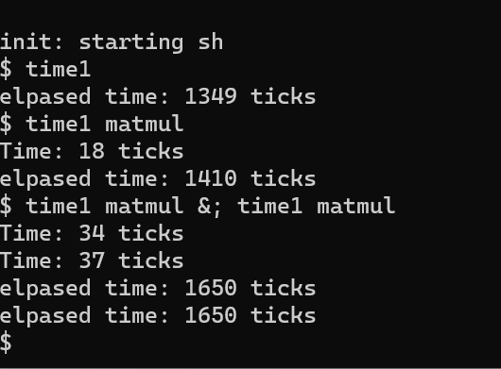
Task 2. Keep track of how much cputime a process has used.
Added cputime field in proc.h to keep track of cputime was used for each process
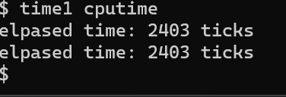

Task 3. Implement a wait2() system call that waits for a child to exit and returns the child’s status and rusage.
Doing this, I mostly learned in the interaction between user and kernel. I implemented wait2() sys call following the wait() sys call.
Task 4. Implement a time command that runs the command given to it as an argument and outputs elapsed time, CPU time, and %CPU used.
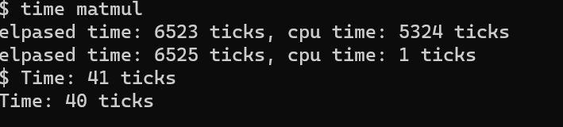

Extra Credit (5 points). Discuss limitations of our time command.
The limitations are that we are not taking account for the execution of the child processes created by command being timed. If the main command makes a child processes, their execution time will not be included in the output of the time command as time only measures the time spent in main process, and not in the child process.

